“**ADS: Assignment – 1**”

1. Write a Java Program to find GCD of two given numbers

Code:

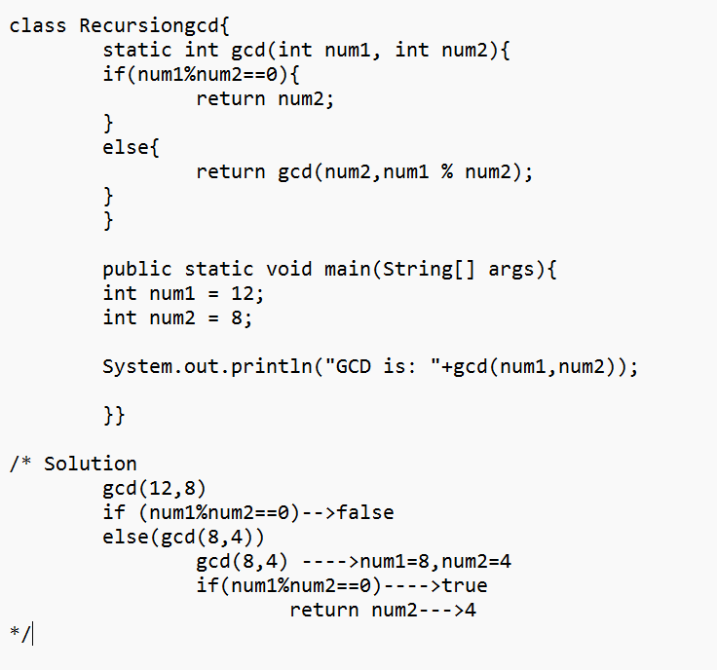

Output

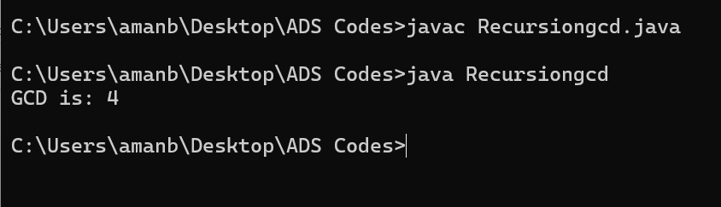

1. Write a java program to LCM of TWO given number.

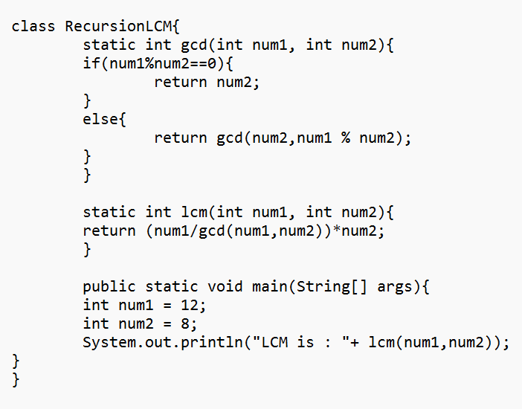

Output:

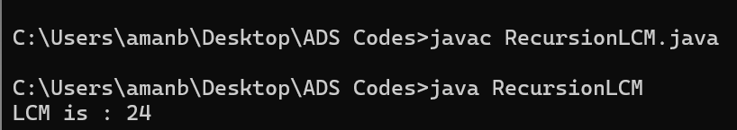

1. Write a Java Program to print all the Prime Factors of the Given Number.
2. 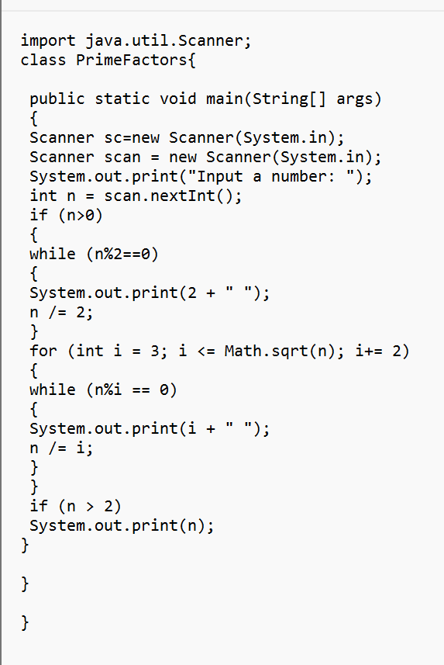

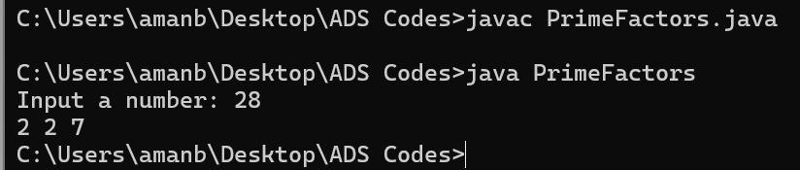

4 Check whether the Given Number is a Palindrome or NOT.

Code:

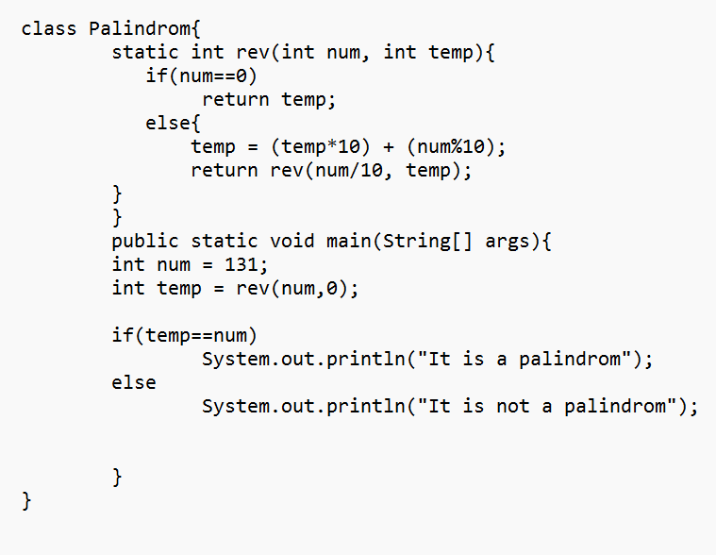

Output:

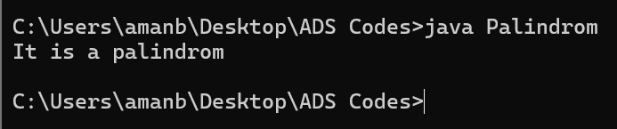

1. Write a Java Program to check whether the Given Number is Prime Number or NOT.

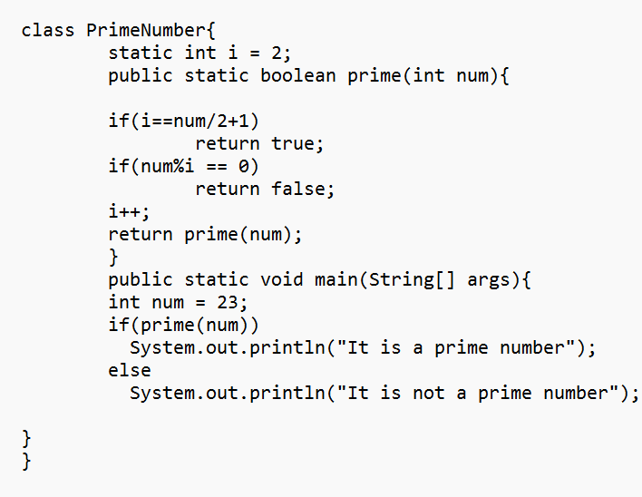

Output:

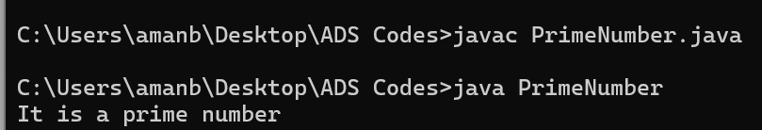

1. Write a Java Program to check whether the given number is Armstrong Number or NOT

Code:

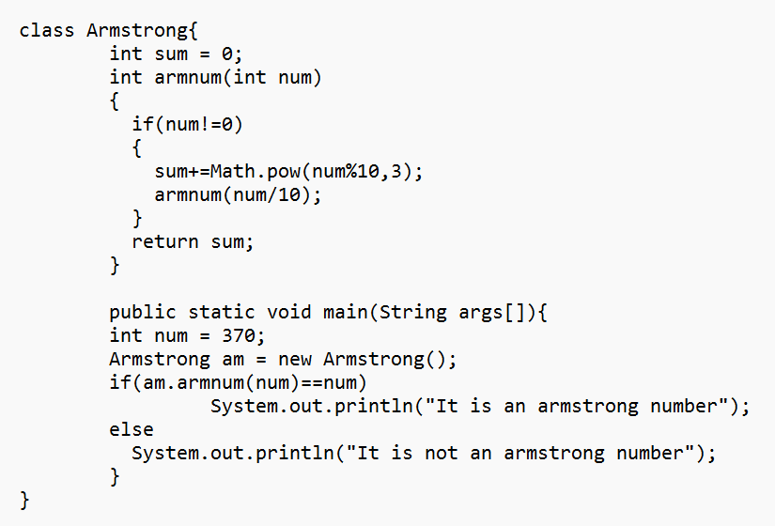

Output:

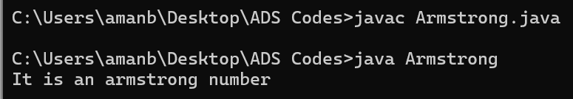

7. Write a Java Program to check whether the given number is Perfect Number or NOT.

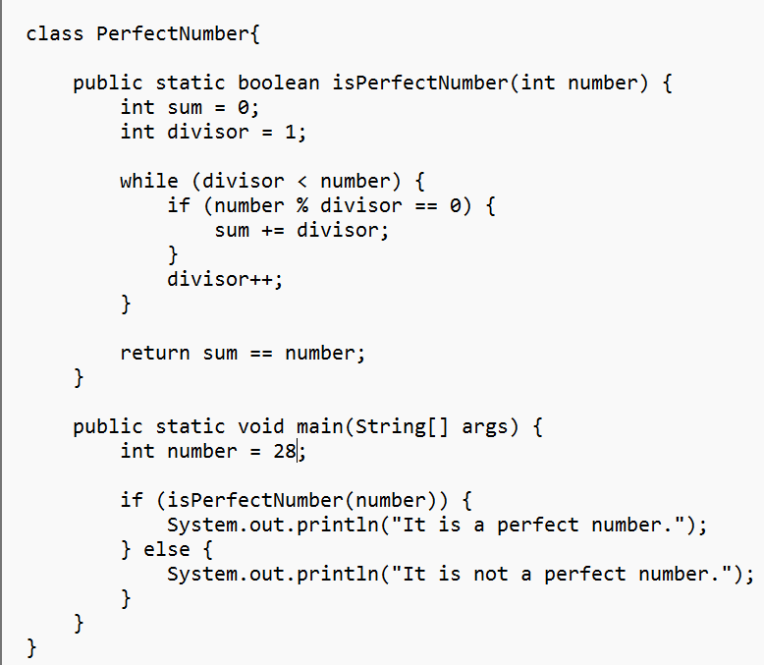

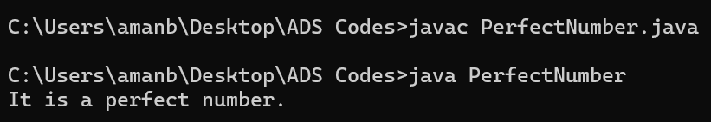

8. Write a Java Program to check whether the given numbers are Amicable Numbers or NOT.

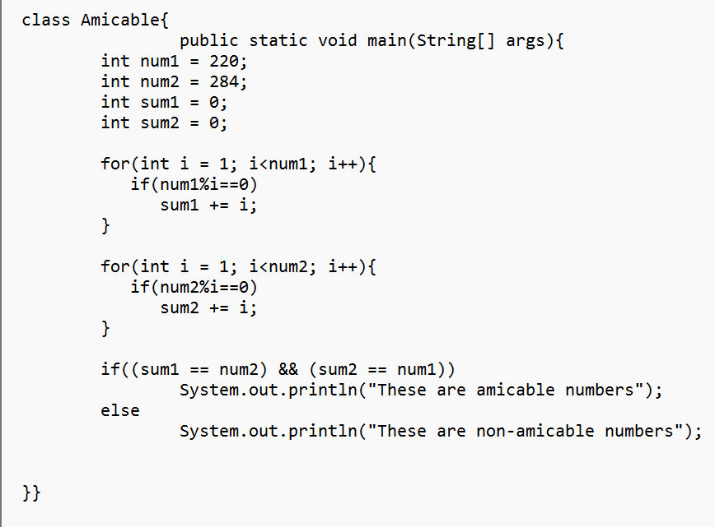

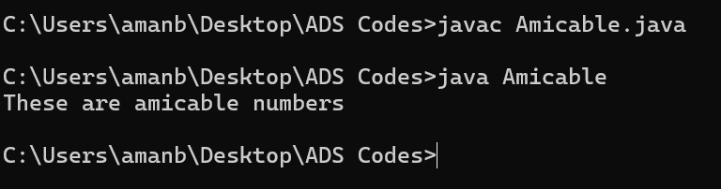

9. Write a Java Program to check whether the given number is Ramanujam's Number or NOT.

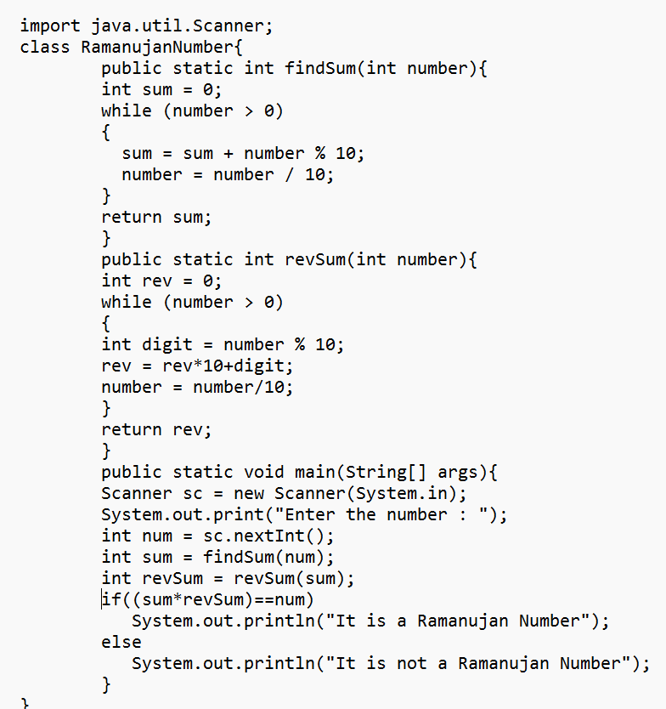

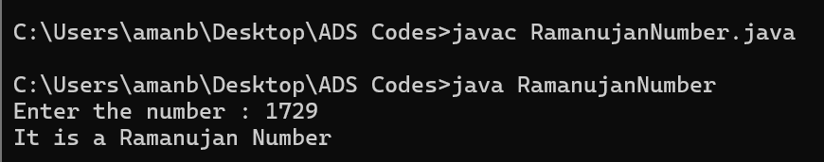

10. Write a Java Program check whether the given number is Automorphic Number or NOT.

